
North Bengal International University

Lab Report: 03
Exp Name : A program to delete a specific element from an array using c program .

Subject : Data Structure
Subject Code : CSE 0612-2131

Submitted By:
Name : Md. Tanvir Rahman Pranto
Dept : CSE
Roll : 0712340012101005
Semester : 2nd Year, 4th semester.

Submitted To:
Name : Saifur Rahman
Designation : Lecturer
Dept : CSE
Date :

Code:
#include <stdio.h>

int main() {
int a[6] = {1, 2, 3, 0, 8, 5};
int n = 6, x, i, j, found = 0;

printf("The given Array: ");
for (i = 0; i < n; i++) {
printf("%d ", a[i]);
}
printf("\n");

printf("Enter element to delete: ");
scanf("%d", &x);

for (i = 0; i < n; i++) {
if (a[i] == x) {
found = 1;
for (j = i; j < n - 1; j++) {
a[j] = a[j + 1];
}
n--;
break;
}
}

if (found) {
printf("After deleting an element from Array: ");
for (i = 0; i < n; i++) {
printf("%d ", a[i]);
}
printf("\n");
} else {
printf("Element not found!\n");
}

return 0;
}

Output:
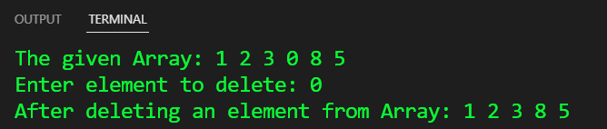

Conclusion: This program deletes a specified element from an array by shifting remaining elements left. It ensures valid input, maintains array structure, and efficiently removes the target value. Simple and effective

